Левченко Галина Александровна
ГБООУ-казачий кадетский корпус
«Стародубский казачий кадетский корпус
им. Героя Советского Союза А.И.Тарасенко»
Учитель английского языка

План-конспект урока английского языка в 7 классе
Тема: «Защита окружающей среды»

Цель: Создать содержательные и организационные условия для усвоения материала по теме: «Защита окружающей среды»
Задачи урока:
- Образовательная- Отработать и закрепить введенную лексику по теме, обсуждать проблемы по данной теме в монологических и диалогических высказываниях;
- Развивающая- Развивать активность на уроке навыков аудирования, устной речи, обучать делать выводы;
- Воспитательная- Прививать чувство бережного отношения к окружающей среде, воспитывать у учащихся активную жизненную позицию.
Форма обучения: групповая, индивидуальная.
Оснащение урока: компьютер, проектор, компьютерная презентация, карточки с заданиями.
Ход урока.
1.Орг.момент.
T: Good morning, my dear. I’m very glad to meet you here.
P: Good morning, my teacher. We are glad to meet you, too.
T: About two hundred years ago people lived in harmony with nature because industry was not much developed. But progress does not come to a standstill. Now industrially developed states cannot ignore the problem of environmental protection. At today lesson we’ll speak about our planet and the things, which threaten it. Do you agree that our planet is our home?
P: Sure. Yes, of course.
T:Is it important to think and to act today if we want to save our home?
P: I think, yes. It’s very important because our children will live on the some planet, I suppose.
T: Then look at the blackboard read this quotation and try to translate it.
II. Фонетическая зарядка.
“ Mother Planet is showing us the red warming light-“be careful” –she saying. To take care if the is to take care of our own house.” The Dalai Lama
III. Беседа о проблемах окружающей среды.
T: And now I’d like to discuss our theme. Tell me, please. What are the names of the environmental of today?
P1,2,3: Litter, air pollution, overcrowding, overpopulation, endangered species, animals which are almost extinct, destruction of natural resources.
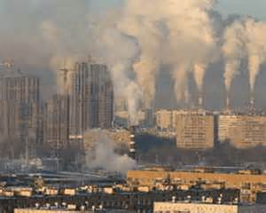
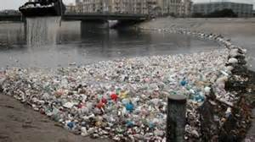
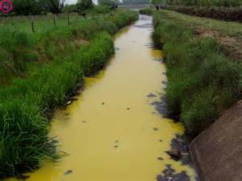
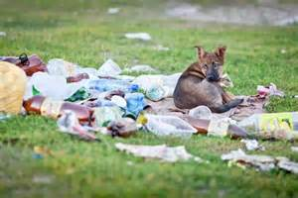
T: Yes, you are right. Can you guess which of these problems I’m going to
describe? This problem is by dumping wastes into lakes, rivers and other bodies of water. They can spread many diseases.
P1: It’s water pollution.
T: Every day people throw amazing amount of garbage and trash.
Tourists leave used cans and bottles in the forests, the owners of private houses in the countryside get rid of their plastic bags and trash throwing them to the out-of-the- way places, far from their gardens.
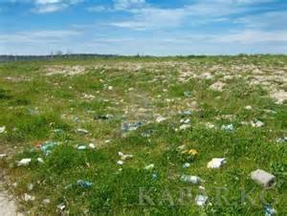
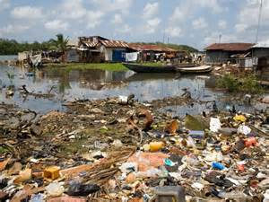
P2: It’s to my mind, a problem of waste and pollutions of our cities and forests.
T: Can you , please, describe the following problems? For example, destruction of nature resources. Can you tell me anything about this problem?
P:By the year 2030, they say, 25% of all animals, birds, fish and insects may be extinct. Every year man cuts down more trees to make paper, wood and medicines. Rain forest where millions of animals, insects live are destroyed now too.
T: And what about air pollution?
P: More and more factories, cars, trucks add their “bad breath” to the air. Polluted air causes different diseases in big cities, such as cancer.
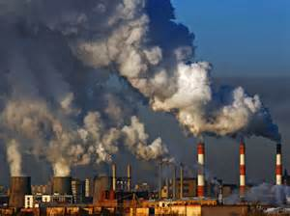
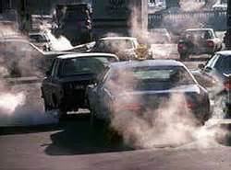

T: Thank you, you are right.
IV.Просмотр проектной работы по данной теме.
T:And look, please at these pictures. You can see pollution of the sea, river, lake and pond. Some of empty bags, tins, plastic bottles that people left here. It is very bad trait of people. What can you say about it?
P: I think we need care about our nature and we must not admin so situation.


P2: As for me, I think that our politics must think about it and do something.
T: Thank you for your replies.
V: Подготовленные выступления учащихся по проблемам экологии.
T: Let me introduce two representatives of “Green Peace” in our area.
They are going to tell you about some things that worry our ecologists.
And also introduce two manufacturers from Belorechensk area and Kurganinsk .
They’ll answer at the questions of people from “Green Pease”. And so let listen them.
P1: We are representatives from so organization as “Green Pease”. Today we are here because we are worry about ecology in our area.
P2:And we’d like to ask some questions to our guests. For the last years our ecology has become more pollution than it was 15 years ago. What do you do at your factories for the cleaning of the air?
P3:It’s very good and urgent question. We have some good cleaning systems at our factory. We take care about our people and about our reputation. And we also think about our children’s future.
P2: Can you take a guarantee of your words?
P3: Of course, I can.
P1:And we have another information. If we look at the statistic we’ll see that in spring the air pollution more than in other season in the year.
P2:(Учащийся показывает рисунки, на которых изображены овощи подвергшиеся весенними выбросами загрязненной экологии)
For example, look here. This is a cabbage and a radish. From the pollution air and acid rain it has spoiled, because a lot of factories have not good filter at nuclear power stations.
P1: I’d like to ask you about litter. Where do you export the litter from your factory?
P4: Our workers export the litter in a special territory and then burn it.It’s very convenient and easy.
P1: In the end we have to take one conclude. We all must be attentive to our nature, plants, water, air and other things in our area.
T: Very good, thank you. In the continue of our lesson I’d like to show you about аreally organization of “Green Pease”. Look, please.(уч-ся смотрят презентацию об организации “GreenPease”)

VI. Групповая работа.
(Класс делится на подгруппы по 4 человека. Каждая подгруппа должна сделать коллаж об охране окружающей среды. После чего учащиеся должны предложить решение проблем экологии).
- Parents must teach their children to protect nature, give them an ecology
knowledge.
- Everybody should love animals, plants, birds in our life.
- Each family must not waste energy.
- Each school must organize “Green Club”
- Nobody must cut trees and bushes in the forest.
T: Welldone.
VII.Заключительный этап урока
T: And the last task for you will be one question. Think, please and answer at my question. How green are you?
( учащиеся отвечают на вопрос , приводя примеры)
VIII. Подведение итогов урока
T: Our lesson is over. You are very good pupils. Your mars for today lesson are excellent marks and good marks.
Используемая литература.
1.http://prezentacii.ru
2. www.nsportal.ru
4.www.festival.1september.ru
5.www.moi-talanty.ru
3.www.klassnye-chasy.ru
6. www.moi-universitet.ru
7. www.pedrazvitie.ru
8. www.узнавай-ка.рф

