Ежова Марина Борисовна
МАОУ «Лицей гуманитарных наук»
города Саратова,
Учитель английского языка

Конспект открытого урока в 11 классе.
Тема урока: «COMMUNICATION».

Цель урока: развитие навыков говорения по теме «Средства общения».
Задачи:
- учебный аспект: систематизировать и активизировать у учащихся знание лексики по теме «COMMUNICATION»; развивать навыки продуктивной речевой деятельности, ведения диалога в учебной ситуации и развитие умения работать в парах и группе;
- развивающий аспект: развивать коммуникативные и ораторские способности, навыки анализа, логического мышления, познавательный интерес, умение слушать, информационную компетенцию;
- познавательный аспект: расширять культурно-страноведческие знания учащихся,
- воспитательный аспект: прививать интерес к стране изучаемого языка, формировать позитивное отношение к культуре других стран, повышать мотивацию к изучению английского языка, учить выступать с речью перед большой аудиторией.

Оборудование: компьютер, проектор, экран, презентации, видео, учебные пособия: Laser B2, MacMillan; Across Cultures, E.Sharman, Pearson Longman; Language Leader, Upper-Intermediate, Pearson.

Ход урока
- Организационный момент
Цель: погружение учащихся в языковую среду
Задачи: ввести учащихся в атмосферу иноязычной речи, настроить на работу, снять напряжение.
Warming up
- What’s the news?
- How do you usually get/pass news?
- What means of communication are available nowadays?
- Which of them do you find the most appealing? Why?
- What’s the theme of our today’s lesson?
ANSWER: “Means of Communication”
- Повторение
Учащиеся под руководством учителя повторяют лексику по теме (чтение, объяснение, примеры).
Teacher, “Let’s review the targeted vocabulary on the theme “Communication” (Laser B2, MacMillan, Unit 8 “Communication”)”.

The List of words
- TO BE AHEAD OF SB IN TERMS OF USING TECHNOLOGY; TO BE LEFT BEHIND
- TO TEXT = TO SEND MESSAGES
- SMS=SHORT MESSAGING SERVICE
- AMOROUS TEXTER
- DIGITAL LIFE/DIGITAL WAY OF THINKING
- TO BE OBSESSED WITH TECHNOLOGICAL ADVANCES/COMMUNICATION ; OBSESSION
- TO BE IMMERSED IN DIGITAL TECHNOLOGY
- ULTIMATE TEENAGE ADDICTION=BIGGEST
- TO BE ADEPT AT USING….= SMART
- TECH APTITUDE = OUTSTANDING SKILLS, COMMAND OF…
- DEBATABLE=DISPUTABLE
- TO BE ACCESSIBLE TO SB
- TO PROVIDE A BRILLIANT WAY TO SUBTLY AVOID DOING STH
- TO CATCH ON FAST=TO BECOME POPULAR
- THE ADVANTAGES OF…..FAR OUTWEIGH THE DISADVANTAGES OF….
- TO DO WIHOUT
- PREFER STH TO SMTH
- Контроль выполнения домашнего задания:
- The text “TEXTING” – to read, be ready to discuss the breaking issue covered in the text.
- A presentation “SMS”(individual task)
- To write 10 idioms/proverbs and their equivalents about communication
- Учитель ведет вопросно-ответную беседу по тексту “TEXTING”:
Why do you think the majority of texters are teenagers?
Why do teens enjoy texting so much?
What can excessive texting cause?

What could you suggest to prevent texting injuries?

ANSWER: use a lot of abbreviations

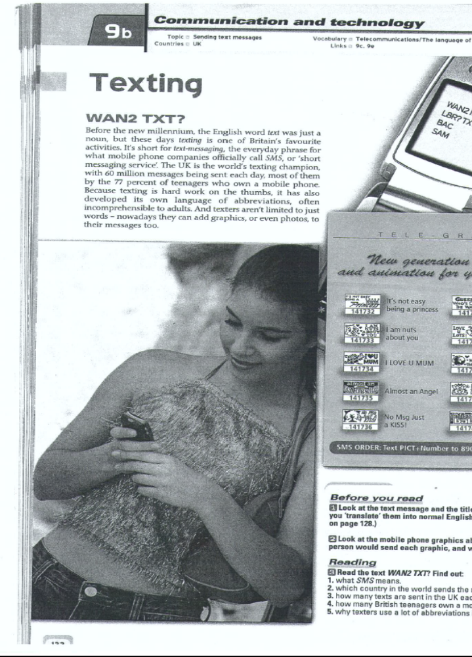

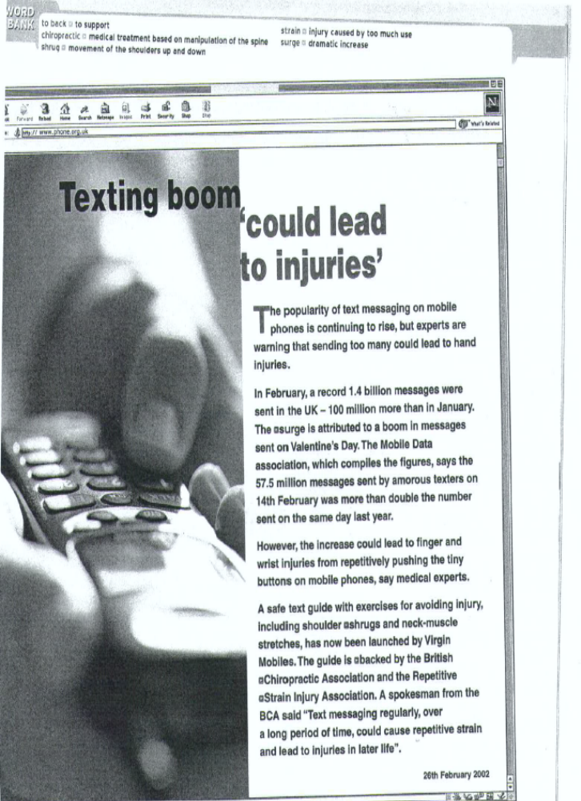

б) Учащиеся смотрят презентацию, обсуждают, делятся своим опытом.

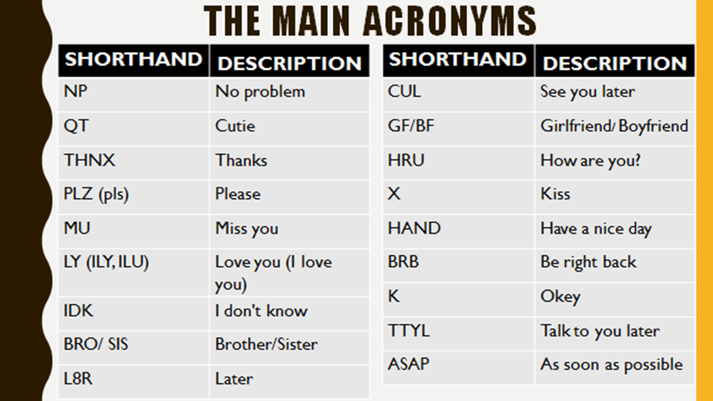
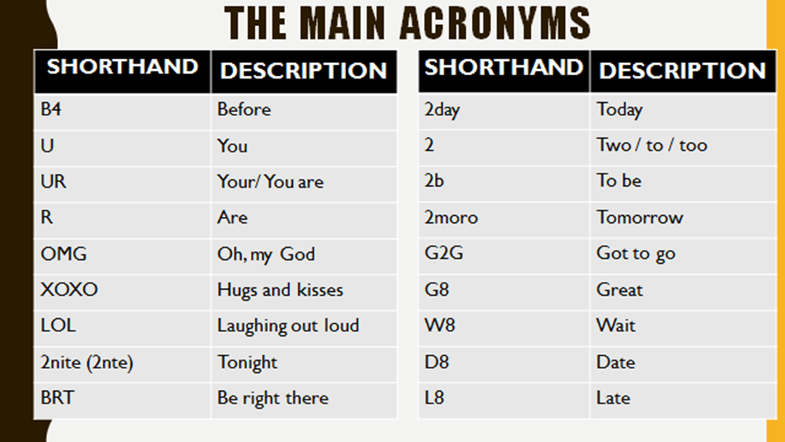


В) Учащийся читает идиомы/пословицы, класс подбирает русские эквиваленты. Учитель предлагает свои примеры.

10 Idioms for Communication you can use with Native Speakers of English

1. ‘ In a nutshell‘ – to summarise briefly Ex: It’s a complicated system, but in a nutshell it works like a kettle.

2. ‘To get straight to the point‘ – to talk about the most important thing Ex: Ok, I’ll get straight to the point. I’m afraid we’re going to have to make some budget cuts.

3. ‘ To put you in the picture‘ – to give the latest information

Ex: Some very important decisions were taken at yesterday’s meeting. Let me put you in the picture.

4. ‘To get the wrong end of the stick‘ – to misunderstand

Ex: If you think that our biggest problem is our distribution channels, you’ve got the wrong end of the stick.

5. ‘To be on the same wavelength‘ – to share similar opinions and idea.

Ex: ‘We agree on most things. We’re very lucky that we are on the same wavelength‘.

Hear it on the Grapevine

6. ‘To hear it on the grapevine‘ – to hear about something passed from one person to another

Ex: I hear on the grapevine that the CEO is planning to resign. Is that true?

7. ‘Can’t make head or tail of it‘ – to fail to understand anything

Ex: This report makes no sense. I can’t make head or tail of it.

8. ‘To talk at cross purposes‘ – to misunderstand

Ex: I think we’re talking at cross purposes. I meant the figures for June not July.

9. ‘To beat about the bush‘ – to delay talking about something.

Ex: Politicians never give you a straight answer. They always beat about the bush.

10. “To get our wires crossed’’ – to misunderstand

Ex: Everyone arrived at different times for the meeting. We must have got our wires crossed.
4.Систематизация лексико-грамматического материала по теме
«COMMUNICATION»
Сравнение средств общения, используемых подростками в России и США.
а) Учитель проводит экспресс-опрос:
- Do you communicate with your foreign peers?
- What means of communication do you use?
- Can you name the most popular means of communication in America?
б) Учащаяся демонстрирует свою презентацию “COMMUNICATION SYSTEM IN THE USA” и задает вопросы по ней:
- What are the similarities between the Russian and American systems of communication?
- What are the differences between the Russian and American systems of communication?
- Which way of communication do you prefer? Why? Etc.
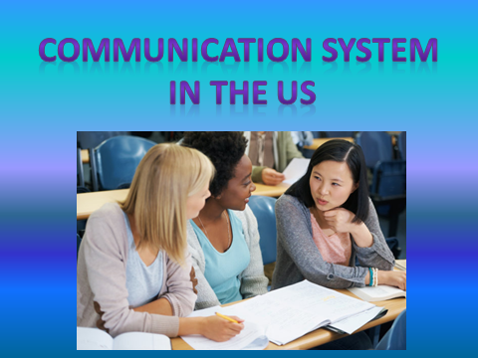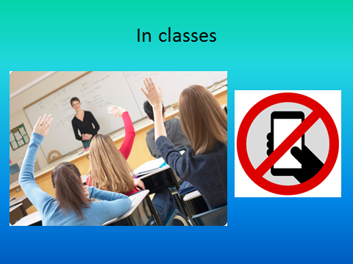
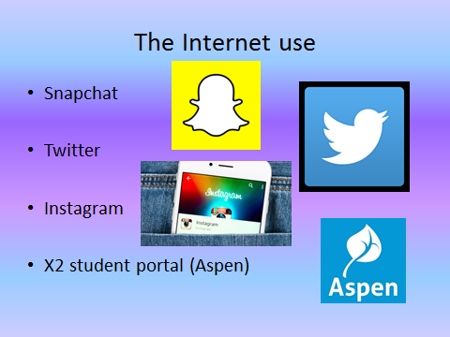

5. Введение нового материала по теме «COMMUNICATION»
- The teacher, ”Let us recap. The up-to-date technological advances used for communication are a significant part of our life. However, they have a great disadvantage: a virtual interaction substitutes an authentic one. Face-to-face communication is losing its popularity. Nowadays communicators (namely teenagers) are obsessed with modern gadgets and we, the older generation, are worried about it. We take this obsession as a disastrous/catastrophic issue. Let’s discuss it.
What skills/qualities should a perfect communicator possess? Why?”
- Учащиеся обмениваются своими мнениями, затем выполняют упражнения №1-4, учебник “Language Leader”, тема №1 “Communication”.
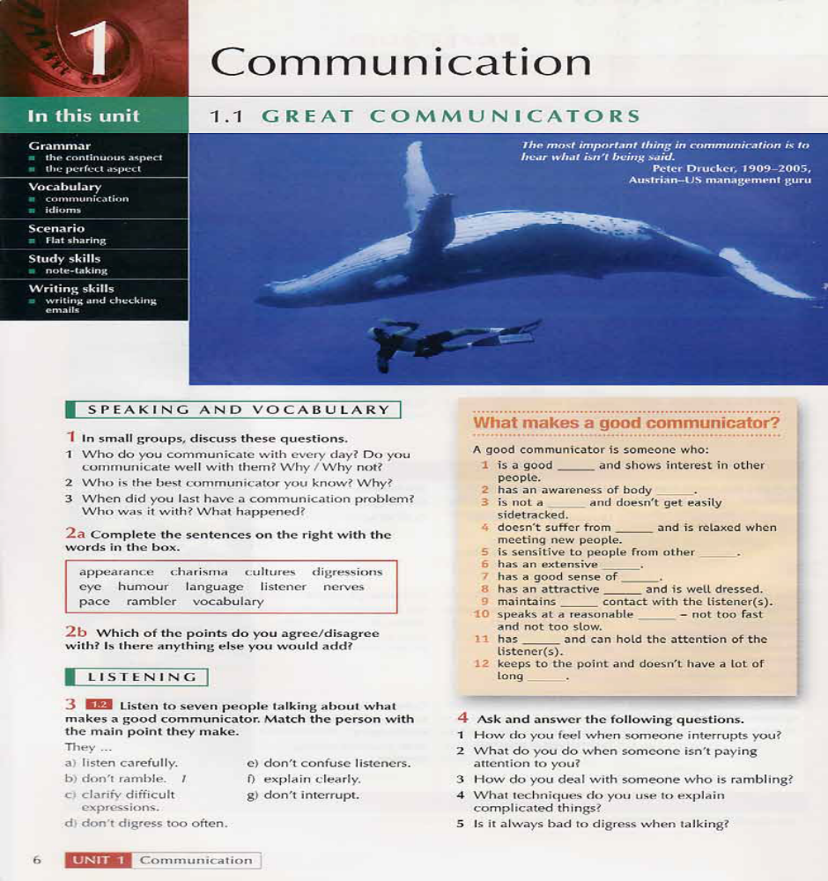

- Пока класс обсуждает навыки необходимые успешному оратору, 2 ученика (юноша и девушка) получают задание подготовить выразительное чтение выдающихся ораторов М.Тетчер и М.Л.Кинга.
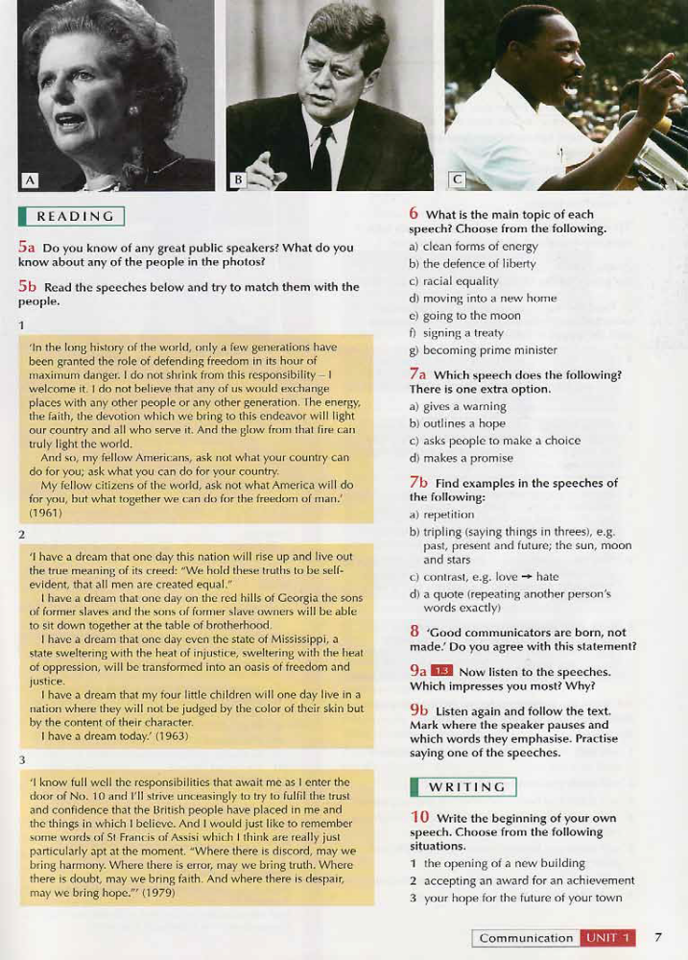
- Учащиеся получают задание прослушать речь известного оратора и определить его без визуальной опоры. Юноша читает известную речь М.Л.Кинга, ученики называют имя. Затем они слушают запись.



- Девушка читает известную речь М. Тетчер, ученики называют имя. Затем они слушают запись.


- Учитель предлагает всем ученикам обсудить услышанное.
The teacher, ”Whose speech do you find more impressive? Why? What makes the speech more convincing?”
Ученики выполняют упражнения №5-8, учебник “Language Leader”, тема №1 “Communication”.

6. Закрепление нового материала по теме «COMMUNICATION»
Ученики выполняют упражнения № 1-3, учебник “Language Leader”, тема №1 “Communication” в парах или группах.
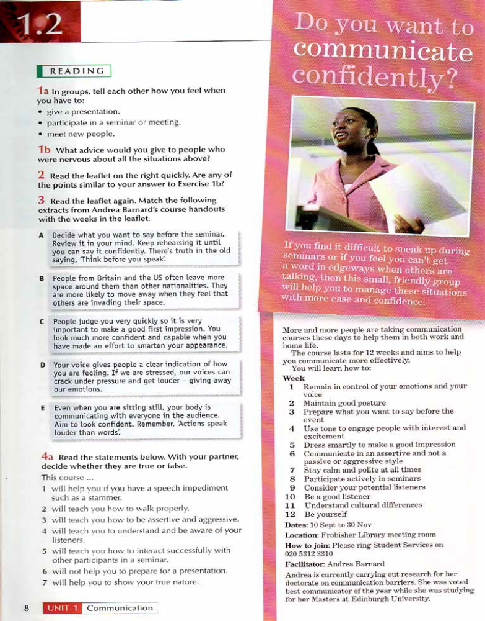Тeacher, “What are the main techniques that make a speech perfect?”
ANSWER: Repetition (I have a dream; no, no, no ), Idioms/proverbs for communication, Words of wisdom/ quotes etc.

Учитель предлагает прочитать и обсудить известные цитаты.
Quotes From Margaret Thatcher

The first female prime minister of Britain, Margaret Thatcher was a controversial figurehead of conservative ideology during her time in office. Politician and former British Prime Minister Margaret Thatcher was born as Margaret Hilda Roberts on October 13, 1925, in Grantham, England. Nicknamed the “Iron Lady,” Thatcher served as the prime minister of England from 1979 to 1990. The daughter of a local businessman, she was educated at a local grammar school, Grantham Girls’ High School. Her family operated a grocery store and they all lived in an apartment above the store. In her early years, Thatcher was introduced to conservative politics by her father, who was a member of the town’s council.
- I love argument, I love debate. I don’t expect anyone just to sit there and agree with me, that’s not their job.
- Disciplining yourself to do what you know is right and important, although difficult, is the high road to pride, self-esteem, and personal satisfaction.
- I do not know anyone who has got to the top without hard work. That is the recipe. It will not always get you to the top, but should get you pretty near.
- You may have to fight a battle more than once to win it.
- Don’t follow the crowd, let the crowd follow you.
- Plan your work for today and every day, then work your plan.
- Look at a day when you are supremely satisfied at the end. It’s not a day when you lounge around doing nothing; it’s a day you’ve had everything to do and you’ve done it
- What is success? I think it is a mixture of having a flair for the thing that you are doing; knowing that it is not enough, that you have got to have hard work and a certain sense of purpose.
- I’m extraordinarily patient provided I get my own way in the end.
- Pennies do not come from heaven. They have to be earned.
- It is not the creation of wealth that is wrong, but the love of money for its own sake.

Тeacher, “Why is it important to speak about outstanding communicators?
You are unlikely to become spokesmEn. But you will definitely need speaking skills when you go to university, pass your exams, give A job interview, interact with your work-mates AND OTHERS.”

7. Домашнее задание:
Handouts “Improving Communication”: ex.4b, 5a, 5b- in written;
Make a speech of an outstanding communicator;
Comment on the quotes from M.Thatcher
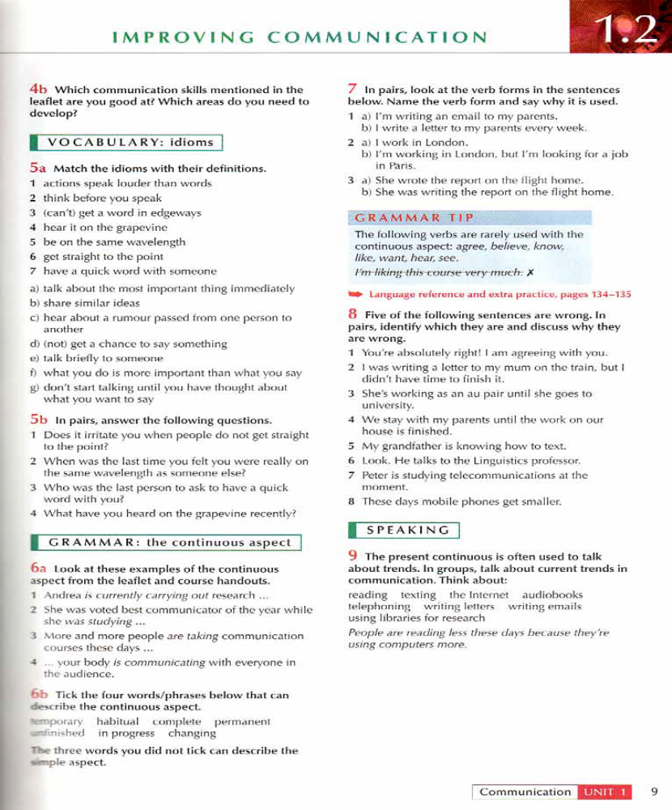

8.Оценки: оценивание работы учащихся с объяснением
9.Рефлексия:
Teacher, “Have you learnt anything new today?”
Учащиеся обмениваются мнениями об уроке.
10. Подведение итогов урока.

